Import New Model

# Overview

This is the process to bulk import a new model when needed. We expect this process will be done every year. This process will not update existing service model records in the system, it will only add new ones.

# Instructions

1. **Flip to main Dynamics CRM app (“Dynamics 365 – custom”)**
   1. Click the down arrow beside Ministry of Education
   2. Select “Dynamics 365 – custom

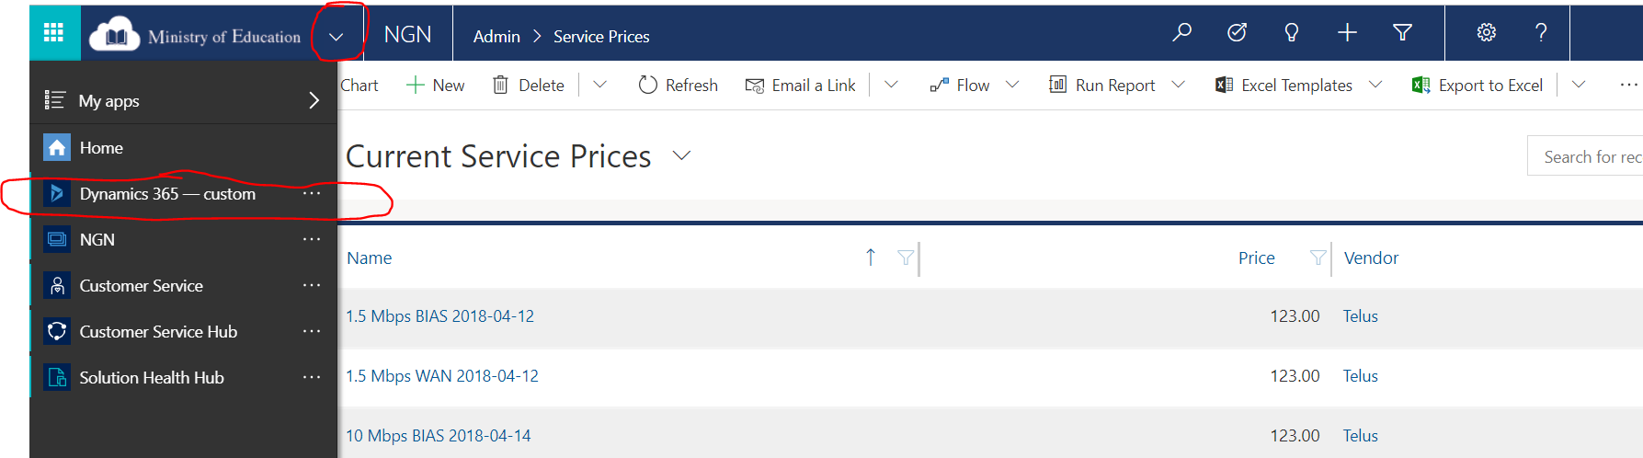

1. **Deactivate current model records**
   1. Go to Advanced Find

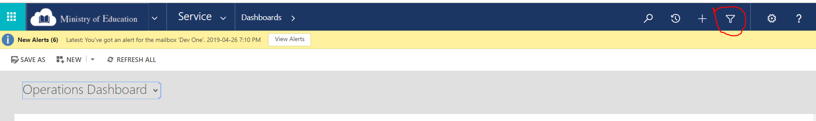

* + 1. Change Look For to “Service Model”

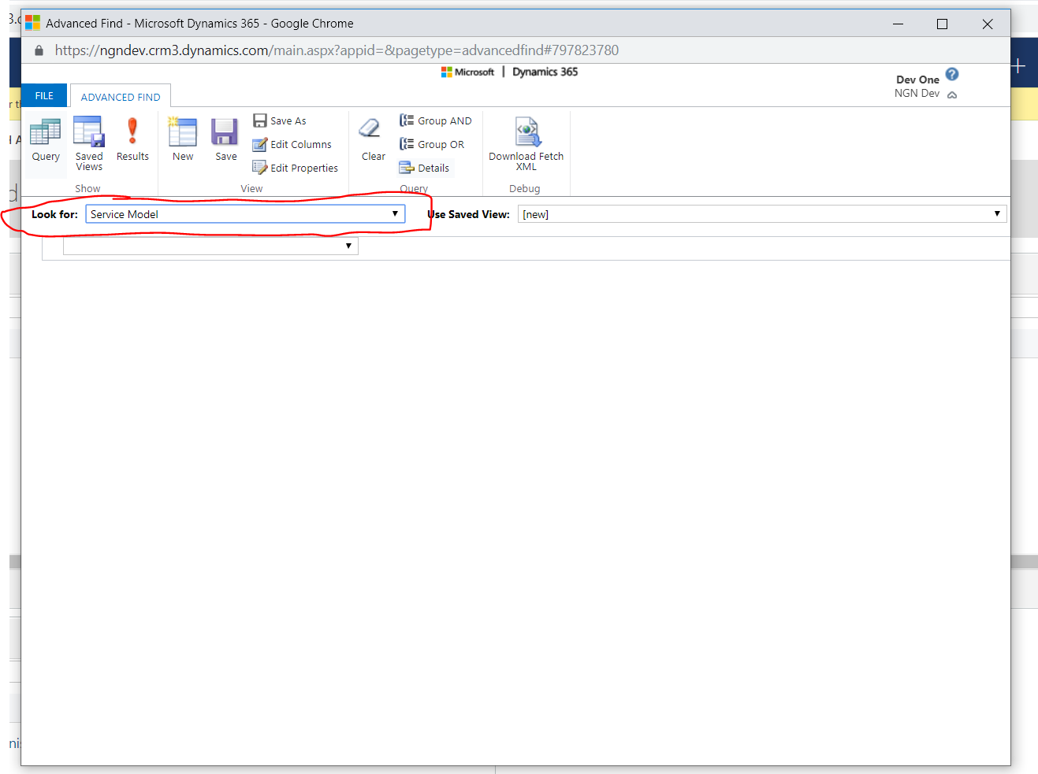

* + 1. Apply filters as needed

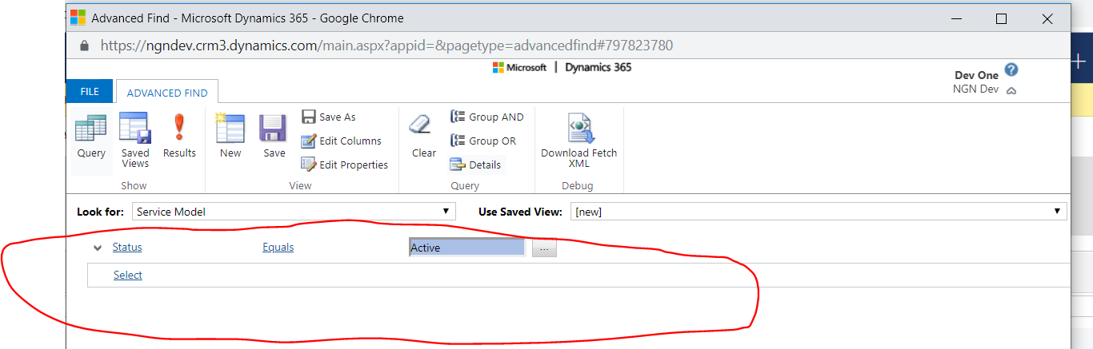

* + 1. Click Results

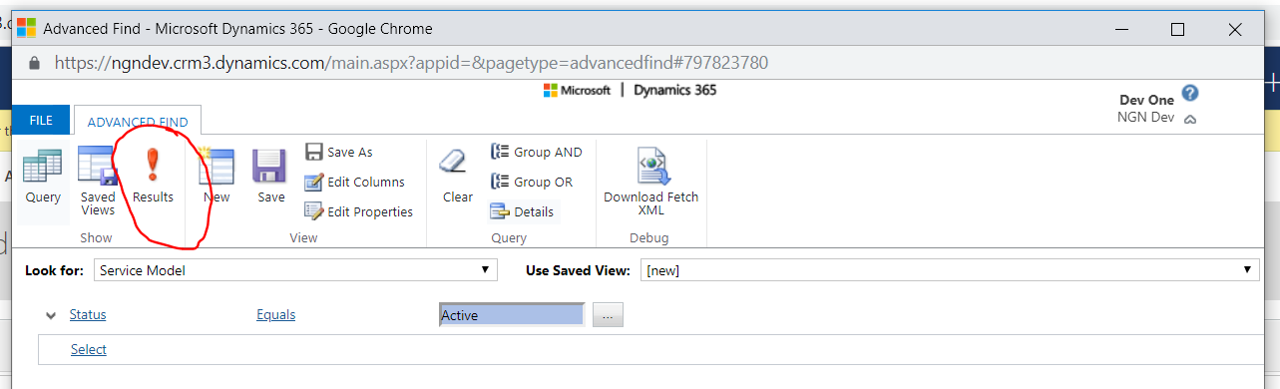

* 1. Select all service models to be deactivated

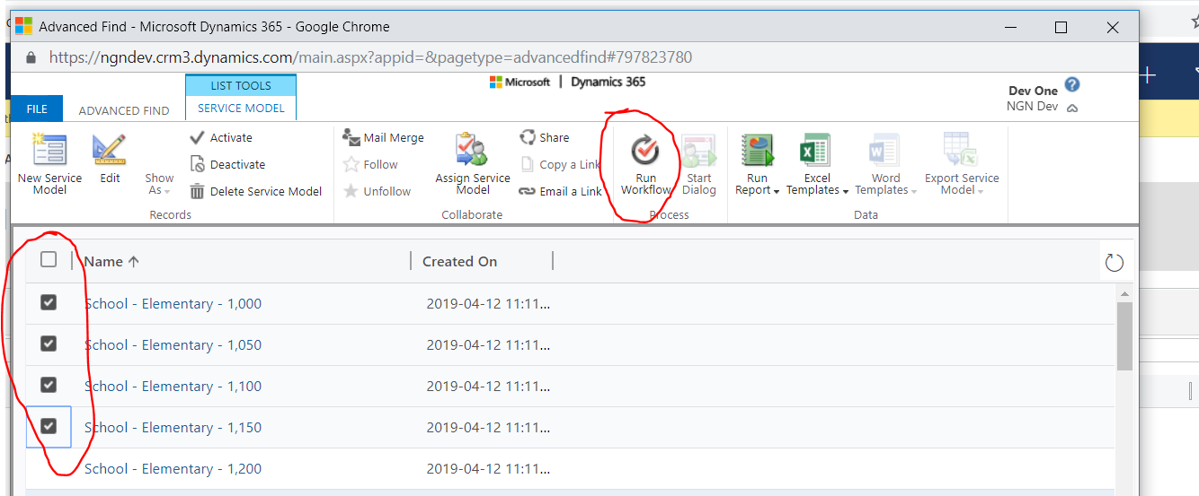

* 1. Click Run Workflow and select “Deactivate Service Model”

1. **Go to Data Management section**
   1. Select Settings
   2. Select Data Management

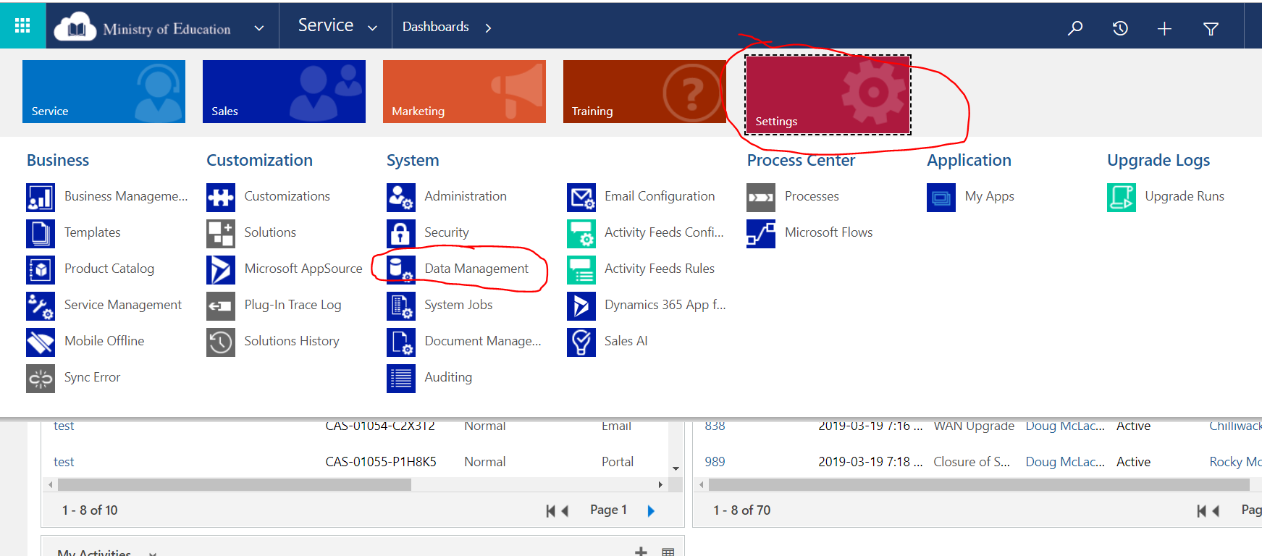

1. **Get a template for Service Model**
   1. Select “Templates for Data Import” 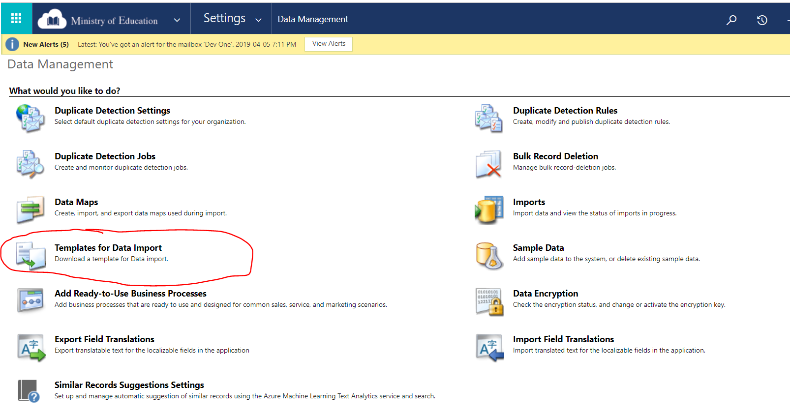
   2. Select “Service Model

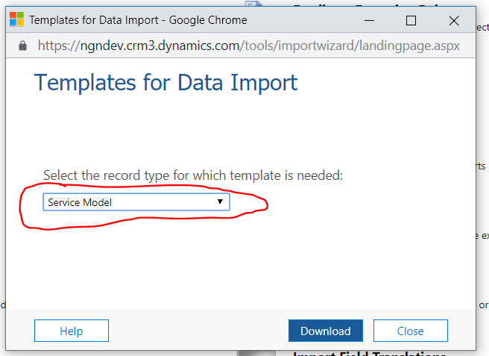

* 1. Click Download

1. **Fill in the excel document**
   1. Enable Editing if needed (yellow box on top of excel document)
   2. Leave the “Name” blank
   3. Enter the “Site Type” (needs to match site types in CRM, aka “School - Elementary”)
   4. Enter the “Maximum Enrolment”
   5. Enter the new “Service” (needs to match service names in CRM, aka “100 Mbps WAN”)
   6. Leave the “Owner” blank
   7. Save the file
2. **Import the File**
   1. Select Imports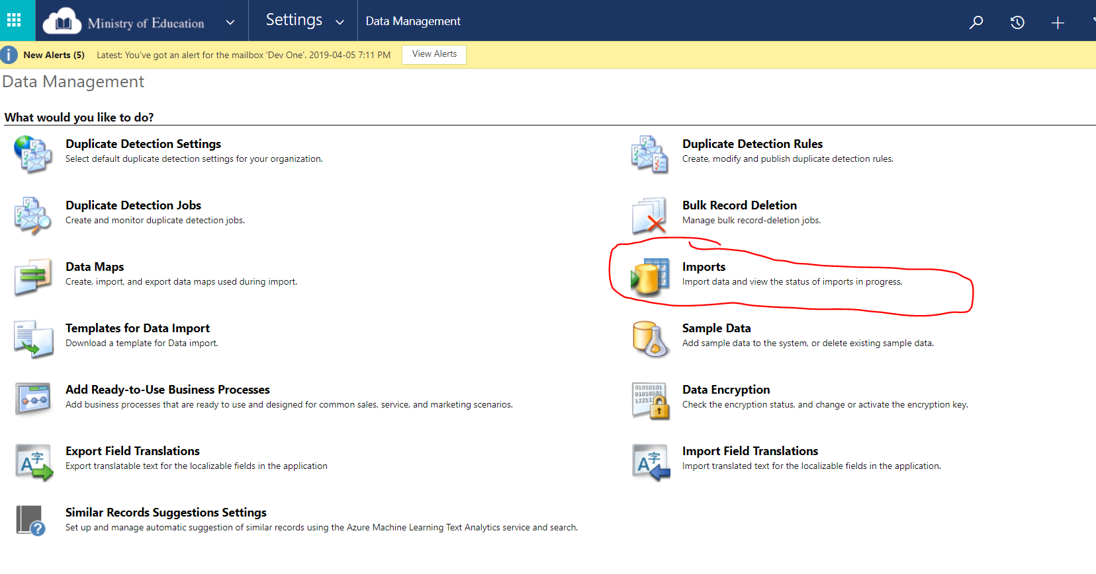
   2. Click Import Data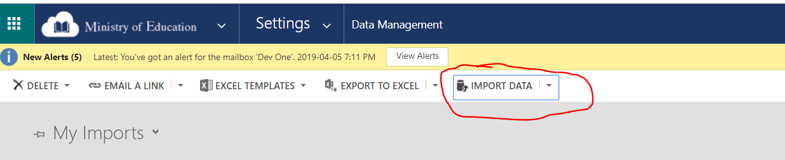
   3. Select your file and click Next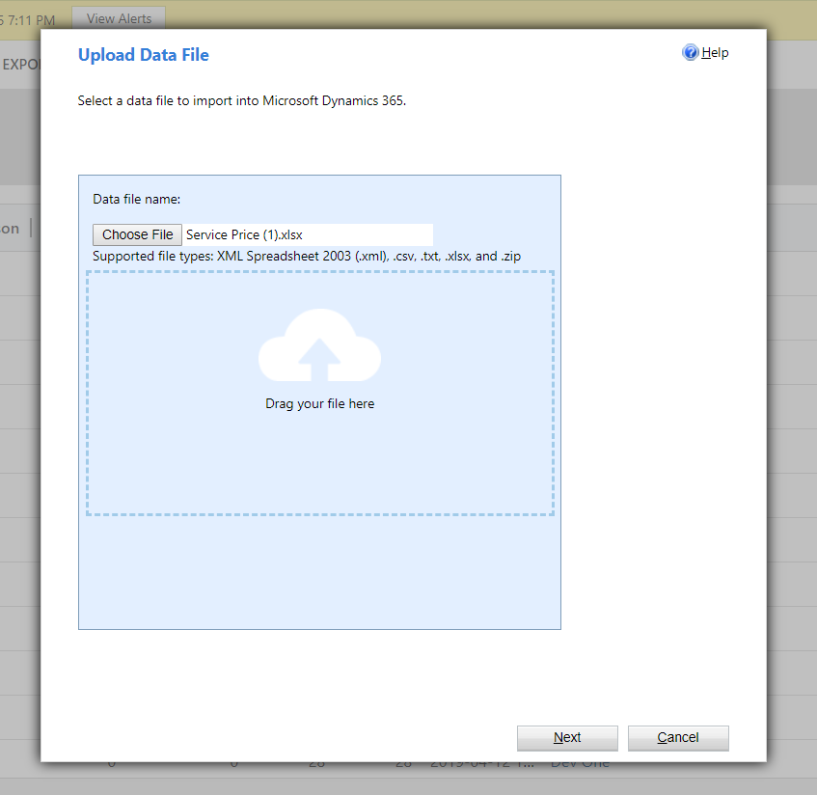
   4. Click Submit
   5. Click Finish
3. **Check if Import Worked**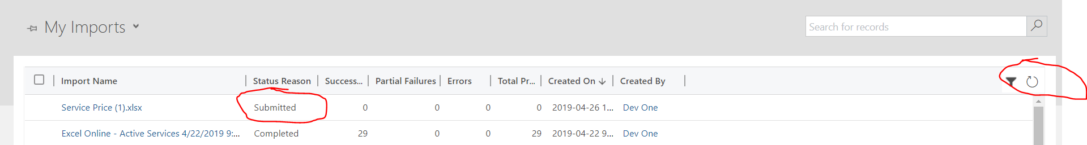
   1. Your import will be displayed under My Imports with a status of Submitted. It will take a few minutes to complete.
   2. Click the refresh button to see the updated status.
   3. If the Import failed, double click on the record to find out why
4. **Update Site Recommended Model**
   1. Go to Advanced Find (detailed instructions in Step #2)
   2. Look for Sites
   3. Filter to all active sites (Statecode equals Active)
   4. Select all
   5. Click Run Workflow and select “Update Recommended Model”

# Troubleshooting

1. Follow step #7 to check if the import worked.
2. Then double click on the import record and select either “Failed” or “Service Prices Partially Imported” on the left side of the screen.

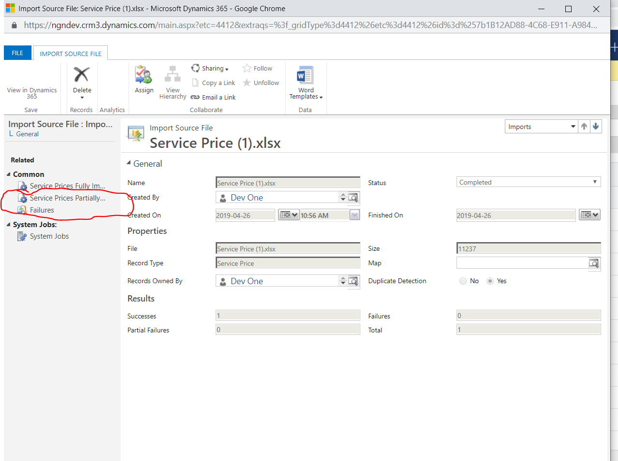

1. For Failed records
   1. Most likely you will see a message saying “The lookup reference couldn’t be resolved” and a Column Heading of either Service or Site Type. This means it couldn’t find a matching Service or Site Type record.
   2. Double check your spelling and create a new import file with only these failed records.
2. For Partially Imported records
   1. Review what the error is
   2. Manually update the record